Problems - Software Engineering
- The range of LOC estimates for the 3D geometric analysis function is optimistic, 4600 LOC; most likely, 6900 LOC; and pessimistic, 8600 LOC. Calculate the expected value for the estimation variable.
pg. no : 700

//S = (Sopt + 4* Sm + Spess) /6

Answer:
// Applying Equation 26.1, the expected value for the 3D geometric analysis function is 6800 LOC.

- Estimated LOC count is 56,100 . Assuming that your organization produces 450 LOC/pm with a burdened labor rate of $7000 per person-month, find the cost /LOC, total estimated project cost and estimated effort in person months.

Pg.no-702
Cost per LOC = Labor rate per month/LOC per pm
Total Estimated Project Cost = Estimated LOC * Cost per LOC
Estimated Effort in pm = Total Estimated Project Cost/ Labor rate per month

3. Use the COCOMO II model to estimate the effort required to build software for a simple ATM that produces 12 screens, 10 reports, and will require approximately 80 software components, Percentage of reuse is 20%, Value of Prod=9. Use the application composition model with object points.

Pg710
To Compute:
Object points = screen+report+components
NOP = Object Points * [(100 - % reuse)/100]
Estimated Effort = NOP/PROD

4. The software equation is a dynamic multivariable model that assumes a specific
distribution of effort over the life of a software development project. To simplify the estimation process and use a more common form for their estimation model. A set of equations derived from the software equation.

t_{min} = 8.14 (LOC/P^{0.43}) & E = 180 Bt³

Use the software equation to estimate the lawn mowing robot software. Assume that equation is applicable and that P = 8000, LOC=33,580, B=0.28

Pg711
To Compute
t_{min} = 8.14 (LOC/P^{0.43})
E = 180*B*t³

5. If the system is to be built from scratch, there is a 60 percent probability that the job will be difficult. Using the estimation techniques discussed, the project planner estimates that a difficult development effort will cost $450,000. A “simple” development effort is estimated to cost $350,000. The expected value for cost, computed along any branch of the decision tree, is Expected cost =∑ (path probability)i * (estimated path cost)i.
Expected cost _{build}=0.40 ($350k) + 0.60 ($450k) = $410k

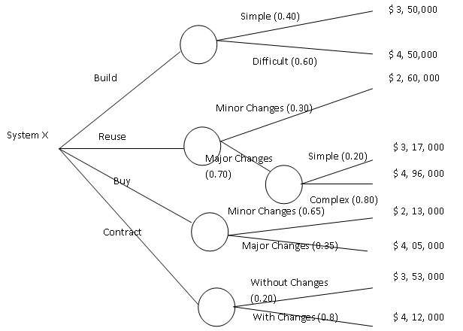

Recompute the expected values noted for the decision tree given above assuming that every branch has a 50–50 probability. Find the appropriate decision by calculating the expected cost to build, reuse, buy, contract.?

Pg716
To Compute
Expected cost _{build}=0.40 ($350k) + 0.60 ($450k) = $410k
Similarly compute reuse, buy, contract.

6. Assume that the software team defines a project risk in the following manner:

Risk identification. Only 70 percent of the software components scheduled for reuse will, in fact, be integrated into the application. The remaining functionality will have to be custom developed.
Risk probability. 50 percent (likely).
Risk impact. reusable software components were planned. If only 70 percent can be used, 18 components would have to be developed from scratch (in addition to other custom software that has been scheduled for development). Since the average component is 100 LOC and local data indicate that the software engineering cost for each LOC is $11.50, the overall cost (impact) to develop the components would be
18*100*11.5=$20,700.
Risk exposure: RE = 0.50 * 20,700 = $10,350.
Recompute the risk exposure discussed in above example when cost/LOC is $16 and the
Probability is 60 percent.
Pg 753
To Compute
Risk Exposure = P * C

7. Given, the below adaptation criteria, graded for a new dev project, with low risk, Calculate average TSS and conclude on the degree of rigor that you choose for applying process.
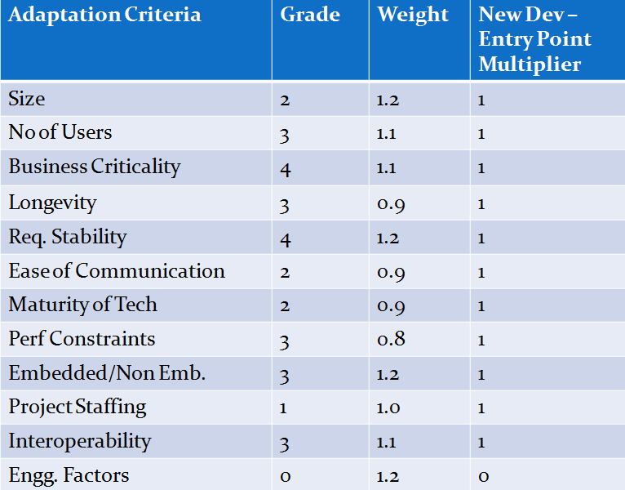
FYI - TSS < 1.24 – Casual, TSS between 1 and 3 – Structured, TSS > 2.4 – Strict, Preferred in the market is Structured.

To Compute
TSS = Grade * Weight

8. Earned Value Analysis
Assume you are a software project manager and that you’ve been asked to compute earned value statistics for a small software project. The project has 56 planned work tasks that are estimated to require 582 person-days to complete. At the time that you’ve been asked to do the earned value analysis, 12 tasks have been completed. However the project schedule indicates that 15 tasks should have been completed. Total budget - $80k. The following scheduling data (in person-days) are available:
Task | Planned Effort | Actual Effort | Scheduled Cost | Actual Cost
1 | 12.0 | 12.5 | 1200 | 1250
2 | 15.0 | 11.0 | 1500 | 1100
3 | 13.0 | 17.0 | 1300 | 1700
4 | 8.0 | 9.5 | 800 | 9500
5 | 9.5 | 9.0 | 9500 | 9000
6 | 18.0 | 19.0 | 1800 | 1900
7 | 10.0 | 10.0 | 1000 | 1000
8 | 4.0 | 4.5 | 4000 | 4500
9 | 12.0 | 10.0 | 1200 | 1000
10 | 6.0 | 6.5 | 6000 | 6500
11 | 5.0 | 4.0 | 5000 | 4000
12 | 14.0 | 14.5 | 1400 | 1450
13 | 16.0 | - | 1600 | -
14 | 6.0 | - | 600 | -
15 | 8.0 | - | 800 | -

Compute the SPI, schedule variance, percent scheduled for completion, percent complete, CPI, and cost variance for the project.

Pg – 740, 742, 27.12
To Compute
SPI = BCWP/BCWS
SV = BCWP – BCWS
Percent Scheduled = BCWS/BAC
Percent Complete = BCWP/BAC
CPI = BCWP/ACWP
CV = BCWP – ACWP

